MSF Scientific Days 2021: Guidelines for submitting an innovation project
Total wordcount: 550 for presentations. 400 for demonstrations.
Abstract System Opens (window 1) (for submission to all Scientific Days, including MSF Scientific Days International): 23 November 2020.
First Submission deadline: 13 January 2021. This is the deadline for MSF Scientific Days International
Abstract System Reopens (window 2) (for submission to MSF Scientific Days Asia, Latin America & Southern Africa ONLY): 25 February 2021
Second Submission Deadline: 29 March 2021
Please Note: The submission system for MSF Scientific Days 2021 will open twice this year. The first window is for submission to all events (MSF Scientific Days International, Europe, Asia, Latin America and Southern Africa). The second window is for MSF Scientific Days Asia, Latin America and Southern Africa ONLY). If you wish your research or innovation to be considered for MSF Scientific Days International or Europe, it must be submitted in the first window (23 November 2020 – 13 January 2021). If you submit your work during window one there is no need to resubmit during window two as all work will be carried forward for consideration by the editorial committees of MSF Scientific Days Asia, Latin America and Southern Africa.
What is an innovation project?
For the purposes of MSF Scientific Days, an innovation is the creation and implementation of new or novel products, services or strategic approaches. Or, an innovation can mark the advance of an existing product, service, or strategy.
The project doesn't have to be medical in nature, but it must improve the way MSF provides medical care (for example, developing new systems for regenerating boreholes).
Presentations and demonstrations
We are looking for presentation and/or demonstration submissions for MSF Scientific Days – innovations that show evidence of impact, either in the outcomes they bring or in the development of improved processes or understanding for MSF. Applications for both presentations and demonstrations should be submitted via the same submissions process - you will be asked to indicate which you are proposing.

What kind of innovation projects can be submitted as a presentation?
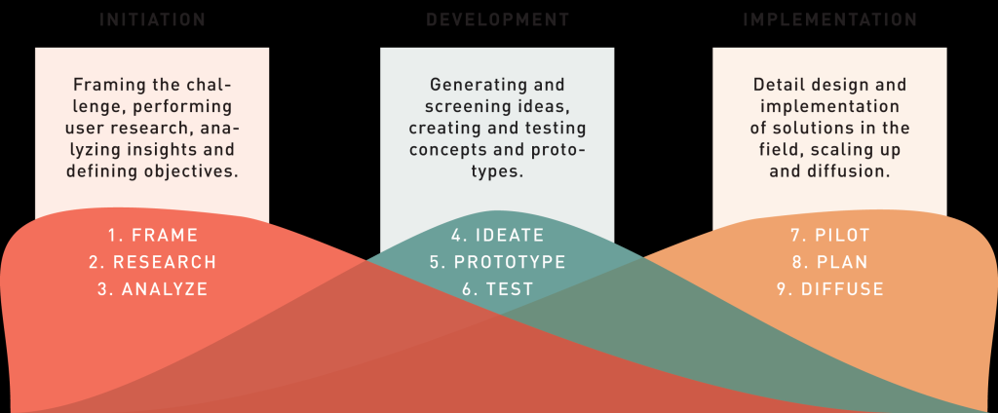
We welcome submissions from all of the above stages. However, we don’t accept proposals to present work which are at the idea or design stage. The MSF Scientific Days are special because they focus on improving our work in the field through evidence and rigorous evaluation / analysis.
What does this mean? It means that, for a presentation, you have developed and tested your innovation (i.e. gathered data to analyse whether it worked and the impact it had or could have), and can submit based on the outcomes, how you achieved them and what they might mean for MSF’s work. A good example can be found here.
We are as interested in ‘failed’ projects as in successful ones. We know that not all innovations achieve the hoped-for outcome or impact - we need to ‘fail forward’ and learn. See a good example here.
You can submit a project at the Initiation or Development stage if you can include learnings from analysis of data. These learnings could be in the form of a new process for MSF or a new perspective on a field challenge. Here are two examples:
Luc has an idea of how to solve a field challenge, but through his analysis of that challenge he finds that it is actually a symptom of a wider problem. He then explores this wider problem and generates a new idea of how to solve it. Because Luc’s project already has relevance for MSF’s work and is based on evidence and analysis, he can submit it as an abstract as long as he can describe how he obtained the evidence and what analysis he did.
Pascale is creating a new tool for nurses in the field. She tests a new approach to developing this tool and subsequently discovers a much more effective way to gather and communicate MSF nurses’ requirements to the design team, meaning time and money are saved. If she can demonstrate through data how that process has improved upon what already exists, she can submit it as an abstract. See an example of this here.
What kind of innovation projects can be submitted as a demonstration?
The demo session is for innovative projects that are ‘work in progress’, where you might not yet have results from testing or implementation, but you have concepts, prototypes or data to share and discuss. It’s a great opportunity to present your project more informally and get feedback from the MSF Scientific Days audience. Demos may also be offered to presenters of oral presentations where the Editorial Committee sees additional benefit from a hands-on demonstration.
If you do have results from testing or implementation from your project, please do submit it a presentation (see below for details).
What are the next steps?
Submit a presentation or demonstration
Please be aware that innovations submitted must be relevant for a medical humanitarian audience. Submissions from other disciplines are welcome, but they must have the objective of improving medical impact.
Discuss your project with a mentor first
We recognise that those of you not involved in research may be unfamiliar with the concept of submitting work in the form of an abstract. If this is the case, and you would like support with the process (or even if you would like to discuss whether your work is relevant to submit), please get in touch via scientificday@msf.org. Please get in touch well in advance of the abstract deadline so that we have time to help.
Your project
Challenge/opportunity
This is where you need to set the scene for the innovation, describing the challenge or opportunity that inspired the innovation and making clear why it is important.
The innovation
This is where you need to describe the innovation you developed, who the 'beneficiary' of the innovation will be and how you planned to measure whether or not you had been successful.
Data collection and analysis
This is where you need to describe how you collected and analysed the data in order to be able to evaluate the success of the innovation, including how you ensured that the analysis was as objective as possible. This is about the method of evaluating and not the results of the evaluation.
Evidence of success and failure
This is where you describe the analysis of the data and what you learned from it. Did it achieve what you hoped? Do you consider it a success? Did it have the predicted impact?
Implications
This is where you look at the bigger picture. What does / should your work lead to? Does it have implications for other areas of MSF’s work? Are there further aspects that need deeper exploring?
Other considerations
All submissions must contain an ethics statement. Innovation projects can involve ethical risks and have consequences for populations even if human participants are not directly involved, therefore the Project Sponsor (or whoever is responsible for oversight of the initiative) should consult the MSF innovation ethics framework to ensure their project is ethically sound.
If your MSF innovation project involved human subjects or their data, this must have ethics oversight by the relevant Medical Director from the Operational Centre responsible for the research. Please see here for MSF ERB (Ethics Review Board) guidance.
In the submission system, you will be asked whether your project involved human participants or their data (for further guidance on this, please consult our webpage on the importance of ethics).
If your project did include human participants or their data, you will need to choose from one of the options below:
- This innovation project is approved by an Ethics Review Board (ERB) – please specify:
- This innovation project fulfilled the exemption criteria set by the Médecins Sans Frontières Ethics Review Board for a posteriori analyses of routinely collected clinical data and thus did not require MSF ERB review. It was conducted with permission from (Medical Director, Operational Centre) Médecins Sans Frontières
- Other – please explain:​
If your project did not include human participants, you will be asked to confirm that you have consulted the Innovation Ethics Framework (or equivalent) to help identify and mitigate potential harms.
Conflicts of interest
You will be asked to declare any conflicts of interest. Failure to disclose these might lead to withdrawal of abstracts or presentations from MSF Scientific Days. All conflicts of interest will be published in the conference booklet.
A conflict of interest exists when professional judgement concerning a primary interest (such as patients’ welfare or validity of research) may be influenced by a secondary interest (such as financial gain).
All authors must disclose any financial and personal relationships with other people or organisations that could inappropriately influence (bias) their work. Examples of financial conflicts include employment, consultancies, stock ownership, honoraria, paid expert testimony, patents or patent applications, and travel grants, all within 3 years of beginning the work submitted.
Financial relationships are easily identifiable, but conflicts can also occur because of personal relationships or rivalries, academic competition, or intellectual beliefs. A conflict can be actual or potential, and full disclosure is best practice.
Agreements between authors and study sponsors that interfere with authors’ access to all of a study’s data, or that interfere with their ability to analyse and interpret the data and to prepare and publish work independently, may represent conflicts of interest, and should be avoided.
All submissions must include disclosure of all relationships that could be viewed as presenting a potential or actual conflict of interest.
If there are no conflicts of interest, authors should tick the box to state that there are none.
Please note, all submitted MSF abstracts will be sent to the relevant Medical Director so that they are aware of what has been submitted.
Authorship
Please ensure that the names of all authors from the research team who qualify for authorship are included in the submission. Note that, wherever feasible, we would expect to see authors from the countries where the research is conducted.
Data reporting standards
If you have quantitative data, give actual numbers, not only percentages. Do not use phrases like ‘around half’ unless supported by underlying numbers. Ensure that the denominator is clear throughout the analysis and include where needed. Means need standard deviations (SDs); medians need interquartile ranges (IQRs). Give 95% confidence indicators (CIs) and p-values where appropriate.
Timeframes
Abstract submission deadline for MSF Scientific Days International and Europe: 13 January 2021
Abstract submission deadline for MSF Scientific Days Asia, Latin America and Southern Africa: 29 March 2021
Feedback
If you have been successful in securing a demo or an oral presentation at the MSF Scientific Days International event you will be contacted by 10th March and asked to confirm participation.
If you have not been successful, you will be contacted by 25th March, but you may still secure a place at the Asia, Latin America or Southern Africa events for which timelines are yet to be confirmed.
Presentation practice
Presentation coaching will be available online prior to MSF Scientific Days. All presenters are encouraged to make the most of the training to ensure that research is communicated as clearly as possible.
Get in touch
If you have any questions, please get in contact with us: scientificday@msf.org

